Final Exam : Project

Design Application as per given Steps and instructions .

Step 1 : Create Database

Create a project with necessary repos (see screenshot at the end.)

Make table that stores required data schema.sql

Make data.sql to store values.

schema.sql
create table orders( orderId int primary key AUTO_INCREMENT,
localD date, localT time,
items varchar(100), quantity int, onHand boolean
);

Data.sql

insert into orders(localD,localT,items,quantity,onHand) values
('2022-02-28','23:59','GiftCard,Car key',5,false);

Application.properties
spring.h2.console.enabled=true spring.datasource.url=jdbc:h2:mem:testdb

Run your code and go to (http://localhost:8080/h2-console) and connect with your database and your database should have stored data inside.

Step 2: Create Required Pojo

Now we have database and let’s create a pojo that we are required to

make.

Make sure It aligns with our database.

Inside of orders pojo
@Data @NoArgsConstructor @RequiredArgsConstructor public class Orders {

private Integer orderId; @NonNull
private String items; @DateTimeFormat(pattern = "yyyy-MM-dd") private LocalDate localD; @DateTimeFormat(pattern = "HH:mm") private LocalTime localT;
private Integer quantity;
private Boolean onHand;

Run the code. It does nothing but make sure there is no error in console.

Step 3: Create DatabaseAccess

It Interacts with schema and our controller class (will be making in next step).

We will create some methods that we will need later. Depends on what you are planning. We are planning here to make such methods that will retrieve all data from our database, method to store data in database, method to edit, delete and update too.
@Repository
public class DatabaseAccess { @Autowired
protected NamedParameterJdbcTemplate jdbc;
// Used to find all stored orders and display in the list
public List<Orders> findAllOrders() {
MapSqlParameterSource namedParameters = new MapSqlParameterSource(); String query = "SELECT * FROM orders order by localD";
return jdbc.query(query, namedParameters, new
BeanPropertyRowMapper<Orders>(Orders.class));
}
// Saves user entered data in database
public void save(Orders orders) {
MapSqlParameterSource namedParameters = new MapSqlParameterSource(); KeyHolder generatedKeyHolder = new GeneratedKeyHolder();
String query = "INSERT INTO orders(items, localD, localT, quantity, onHand) VALUES(:items, :localD, :localT, :quantity, :onHand)";
namedParameters.addValue("items", orders.getItems()); namedParameters.addValue("localD", orders.getLocalD()); namedParameters.addValue("localT", orders.getLocalT()); namedParameters.addValue("quantity", orders.getQuantity()); namedParameters.addValue("onHand", orders.getOnHand()); jdbc.update(query, namedParameters, generatedKeyHolder);
}
// Deletes user order based on OrderId
public void deleteById(Long orderId) {
MapSqlParameterSource namedParameters = new MapSqlParameterSource(); String query = "DELETE FROM orders where orderId = :orderId"; namedParameters.addValue("orderId", orderId);
jdbc.update(query, namedParameters);
}
//Updates individual data
public void updateIndividualOrder(Long orderId, Orders orders) { MapSqlParameterSource namedParameters = new MapSqlParameterSource(); String query = "UPDATE orders SET items=:items where orderId = :orderId"; namedParameters.addValue("orderId", orderId).addValue("items",
orders.getItems());
jdbc.update(query, namedParameters);
}
}

Step 4 – Create Restcontroller

(OrderController) that will be interacting with our database.

(We are going to use this database interaction at later point when we would send index data to the HomeController and that controller will forward data)
@RestController @AllArgsConstructor @RequestMapping("/orders") public class OrdersController {
private DatabaseAccess da; @GetMapping
public List<Orders> getOrderCollection() {
return da.findAllOrders();
}
@PostMapping(consumes = "application/json")
public String postOrder(@RequestBody Orders orders) { da.save(orders);
return "http://localhost:8080/orders/";
}

@PutMapping(value = "/{orderId}")
public String updateOrderIndividual(@PathVariable Long orderId, @RequestBody Orders orders) {
da.updateIndividualOrder(orderId, orders);
return "Updated";
}

@DeleteMapping(value = "/{orderId}")
public String deleteOrderById(@PathVariable Long orderId) { da.deleteById(orderId);
return "Order has been deleted";
}
}

Optional Section

Highly recommended! Use this to see everything is working fine

Using postman service.

Run the code and code shouldn’t display any error in Console.
- Go to (http://localhost:8080/orders) and you should see order there stored in data.sql.

Use postman to delete, post and update (select put, add id at the end and then) Get service Post Service
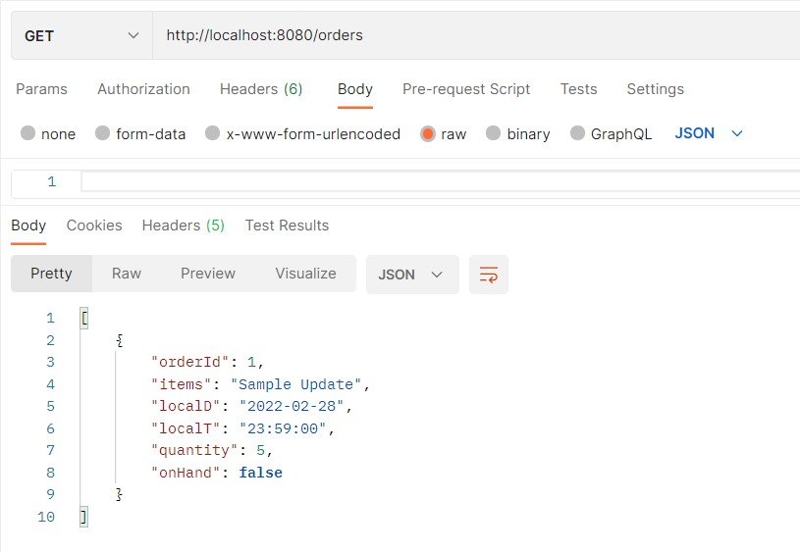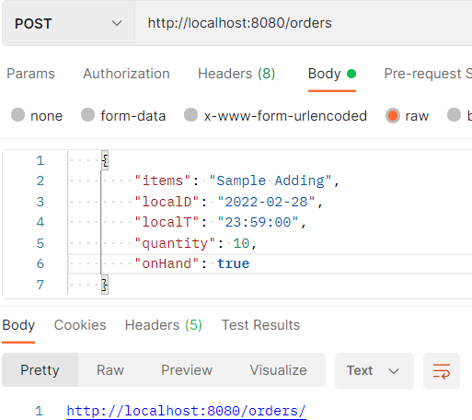

Update service -- There is no specific update method we will use put service
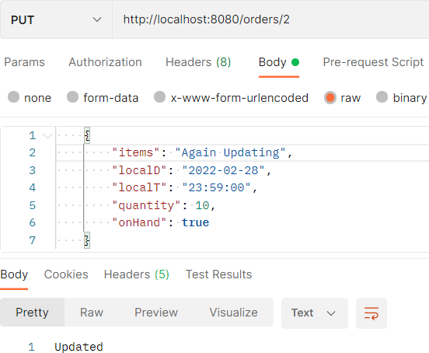

Step 5: Create an index.html page

Make a form to take all the data from user and store it.

We will add more data in step 5 and 6 later.
<html xmlns:th="https://www.thymeleaf.org">
<head>
<meta charset="ISO-8859-1">
<title>Insert title here</title>
</head>
<body>
<h1>Fill in the form</h1>
<form method="post" th:action="@{/insertOrders}" th:object="${orders}">
<input type=hidden th:field="*{orderId}"/><br>
Items: <input type="text" th:field="*{items}" required/><br> Date: <input type="date" th:field="*{localD}"/><br>
Time: <input type="time" th:field="*{localT}"/><br> Quantity: <input type="number" th:field="*{quantity}"/><br>
Do you have this item?: <input type="checkbox" th:field="*{onHand}"/><br>
<input type="submit" value="Add Values!"/>
</form>
</body>
</html>

Step 6: Create a HomeController and other Interections

Make it interect with index.html and RestController.

Run the project and go to localhost and it should display a form to take user input and when you enter data, it should update restful template and our database

At this point we are sending order information from our index page to home controller and home controller is using rest controller to update our database as well as restful template.

Add some data in the form and check restTemplate(…/orders) as well as h2

console to make sure that you are getting data that you are adding in your form. Now we will display the all the data that we are storing inside of our template.

(We will use some rest template to get data and display it on the index page by using javascript. To make this happen, we need a method in restcontroller so we would be able to get individual data from our restful template.
For better understanding: At this point, out code should work fine if we go to
@GetMapping("/")
public String index(Model model, RestTemplate restTemplate) { ResponseEntity<Orders[]> responseEntity =
restTemplate.getForEntity("http://localhost:8080/orders", Orders[].class); model.addAttribute("ordersList", responseEntity.getBody()); model.addAttribute("orders", new Orders());
return "index";
}
@PostMapping("/insertOrders")
public String insertOrders(Model model, RestTemplate restTemplate, @ModelAttribute Orders orders) {
restTemplate.postForEntity("http://localhost:8080/orders", orders,
String.class);
model.addAttribute("orders", orders);
return "index";
}
@GetMapping("/insertOrders")
public String insertOrders(Model model, RestTemplate restTemplate) {

model.addAttribute("ordersList",restTemplate.getForEntity("http://localhost:8080/ord ers", Orders[].class).getBody());
return "redirect:/index";
}

(http://localhost:8080/orders) but if we go to (http://localhost:8080/orders/1) then our code would crash that means we need a method (In Controller + DatabaseAccess) to retrieve individual data from our database and display.

In DatabaseAccess
// Retrieve data based on orderId
public Orders findByOrderId(Long orderId) {
MapSqlParameterSource namedParameters = new MapSqlParameterSource();
String
query = "SELECT * FROM orders WHERE orderId = :orderId"; namedParameters.addValue("orderId", orderId);
return jdbc.query(query,
namedParameters, new BeanPropertyRowMapper<Orders>(Orders.class)).get(0);
}

In our RestController
@GetMapping(value = "/{orderId}") public Orders getIndividualOrder(@PathVariable Long orderId) {
return da.findByOrderId(orderId);
}

Now, if you go to the link (http://localhost:8080/orders/1), it should work fine and show you order data by id.

We will use Javascript to take the input from (…/1, …/2, .../{id} etc) and we will display it inside of our index page at Onlick action. Our page will show title only and when user would click on that then our page will display more details.

On index.html (Before form preferably.)
<table>
<tr>
<th>Item(s)</th>
<th>Date (Sorted)</th>
</tr>
<tr th:each="ord: ${ordersList}">
<td><h4><a href="#" th:onclick="'getOrders('+ ${ord.orderId} + ')'"
th:text="${ord.items}">Orders</a>
<div th:id="'orders' + ${ord.orderId}"></div></h4></td>
<td><h4 th:text="${ord.localD}"></h4></td>
</tr>
</table>

Create script.js file inside of static/js and then put JavaScript code inside (using json) Inside of Script.js

function getOrders(orderId) {
if (document.getElementById("orders" + orderId).innerHTML == "") { fetch('http://localhost:8080/orders/' + orderId)
.then(orders => orders.json())
.then(function(orders) {
var textToDisplay = "<br>";
textToDisplay+= "Date: " + orders.localD+ "<br>"; textToDisplay+= "Time: " + orders.localT+ "<br>"; textToDisplay+= "Quantity: " + orders.quantity+ "<br>"; textToDisplay+= "On Hand? : " + orders.onHand+ "<br>";
//Changing Div Tab
document.getElementById("orders" + orderId).innerHTML =
textToDisplay;
});
} else {
document.getElementById("orders" + orderId).innerHTML = "";
}
}

Load JS file in our index.html in header
<script src="../static/js/script.js" th:src="@{/js/script.js}"></script>

Step 7: Delete an item from index page

We already created delete method inside of our RestController and database, we will use that at this point.

Inside of our HomeController.
@GetMapping("/deleteOrders/{orderId}")
public String deleteData(Model model, RestTemplate restTemplate, @PathVariable Long orderId) {
restTemplate.delete("http://localhost:8080/orders/" + orderId); model.addAttribute("ordersList",
restTemplate.getForEntity("http://localhost:8080/orders", Orders[].class).getBody());
return "redirect:/";
}

Inside of our index page (in the table under <th> and <td> tags)
//Goes under Date(Sorted)
<th>Delete Order</th>
//Goes under <td> tag at the end
<td><a th:href="@{/deleteOrders/}+${ord.orderId}">Delete</a></td>

You should be able to add and delete data using index.html page.

Step 8 : To update/edit data on index.

Inside of restController and DatabaseAccess we already have methods to updateOrders. In our HomeController.
@GetMapping("/editOrders/{orderId}")
public String editOrder(Model model, RestTemplate restTemplate, @PathVariable Long orderId) {
Orders orders = restTemplate.getForEntity("http://localhost:8080/orders/" + orderId, Orders.class).getBody();
restTemplate.delete("http://localhost:8080/orders/" + orderId);

model.addAttribute("orderList",restTemplate.getForEntity("http://localhost: 8080/orders", Orders[].class).getBody());
model.addAttribute("orders", orders);
return "index";
}

Inside of our index.html
//Goes under delete
<th>Edit Order</th>
//Goes under <td> tag at the end
<td><a th:href="@{/editOrders/}+${ord.orderId}">Edit</a></td>

Your whole table should look like:
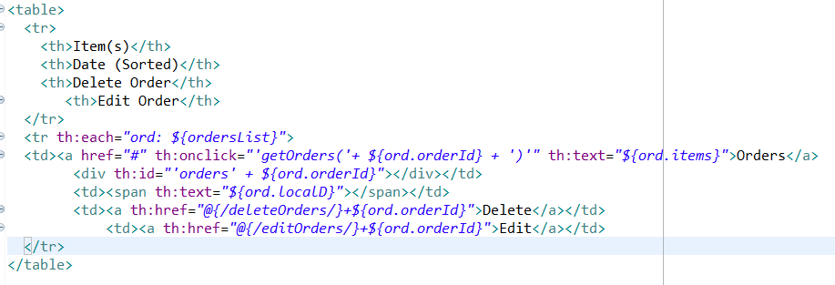

Screenshots (for troubleshooting)

Classes and folders
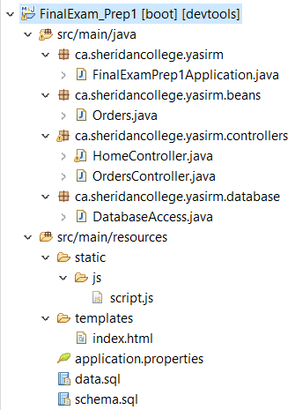

Schema and Data SQL files

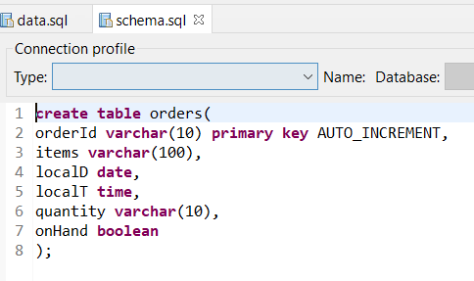

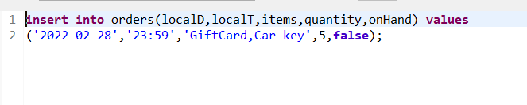

Application properties.
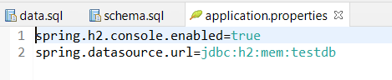

Rest Controller.

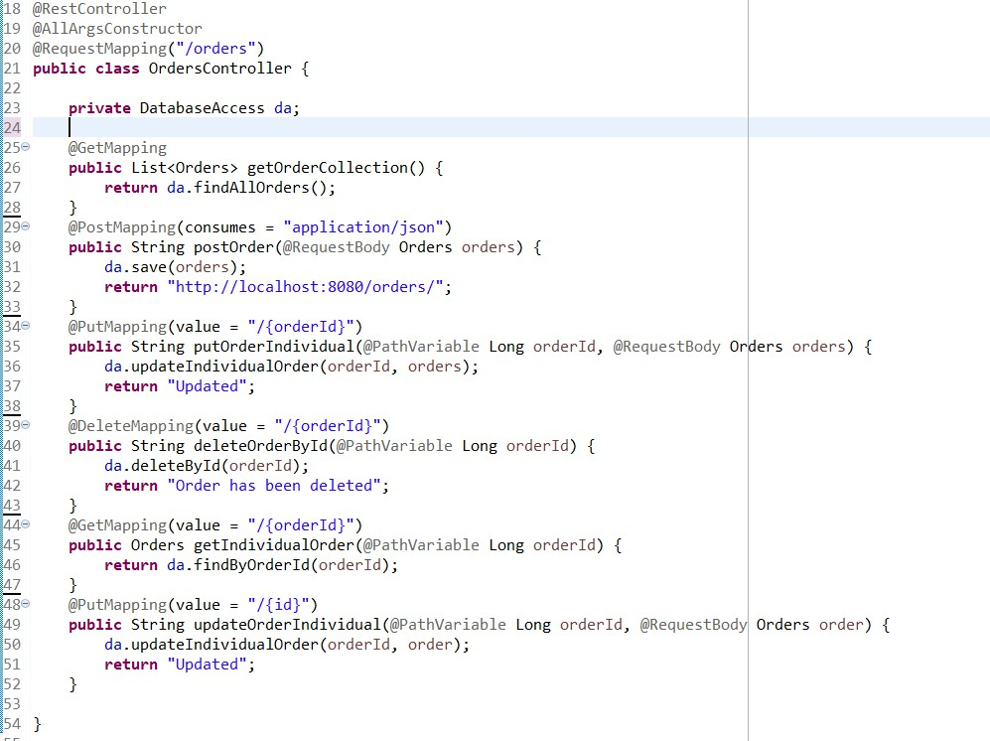

Home Controller
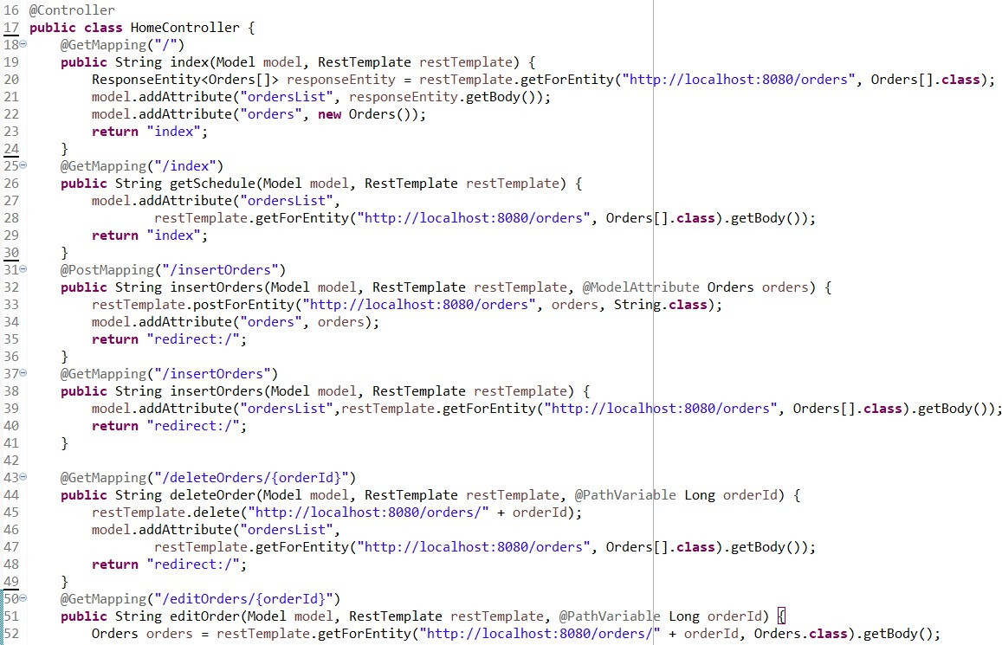
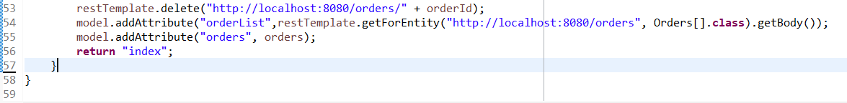

Pojo class.
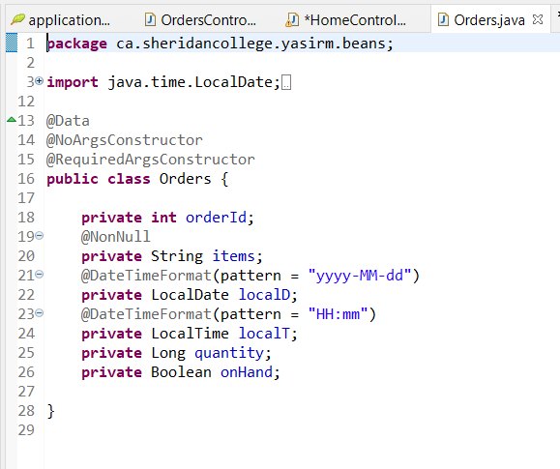

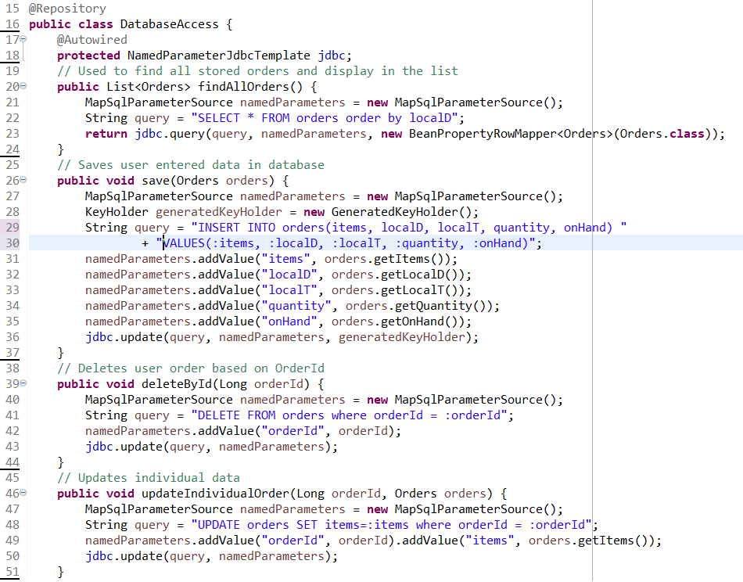
Database Access

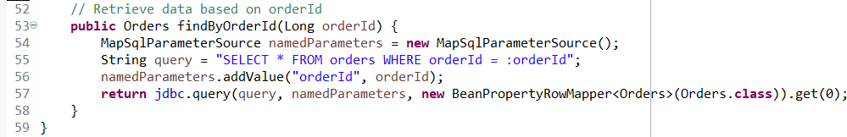

Javascript
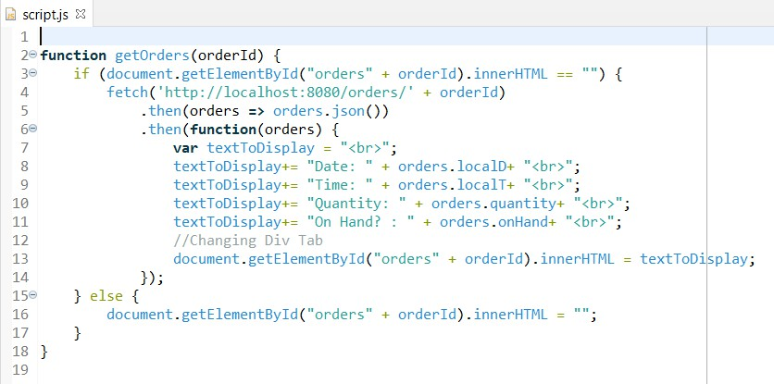

Index page
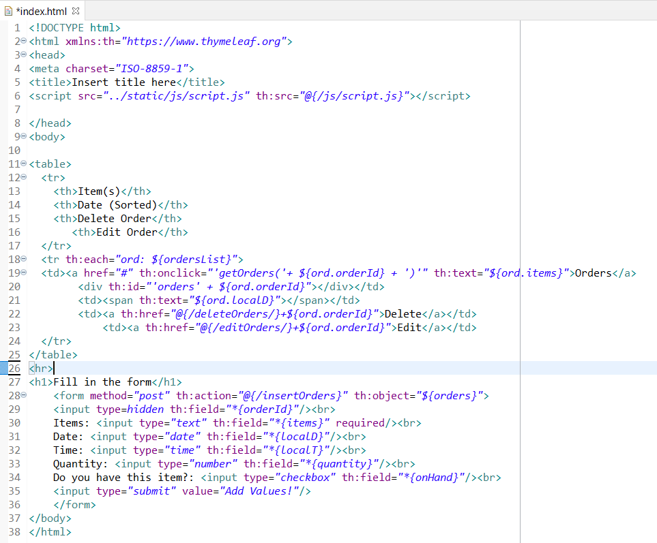

Outputs

Index page
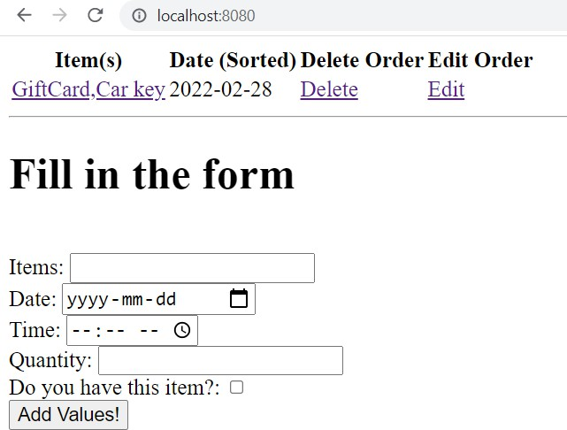

H2 Database
